1. Double click on the save button creates double address on the client end.

Client account: [tamanna.tasnim.akhi+1@gmail.com](mailto:tamanna.tasnim.akhi+1@gmail.com) , pass: july 21

Client account>>address>> Add>> Continue (double click on the “continue” button creates the issue.

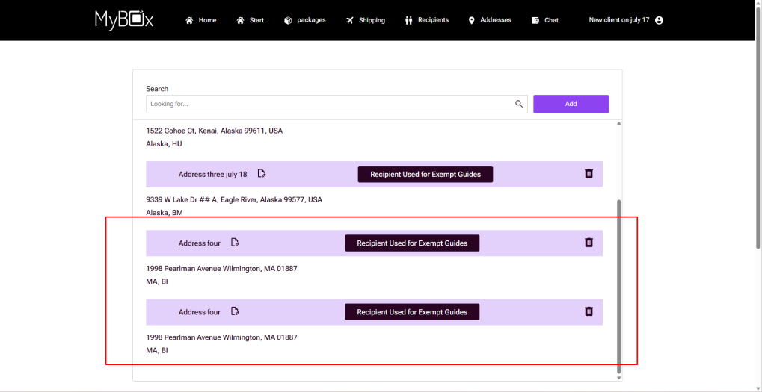

Admin>> package>>add new package>>save button (double click on save button creates double package.

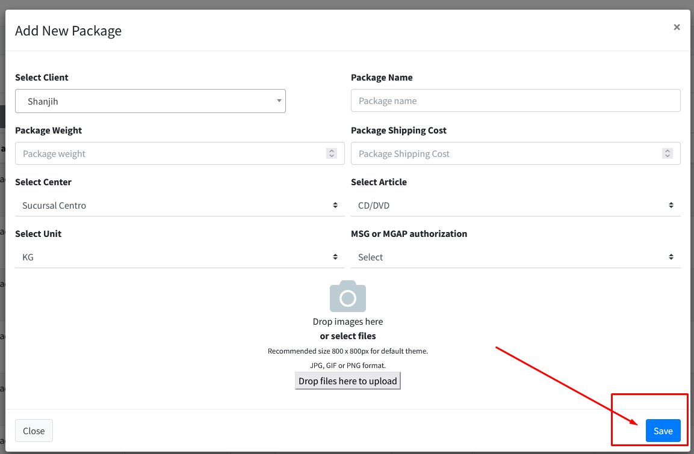

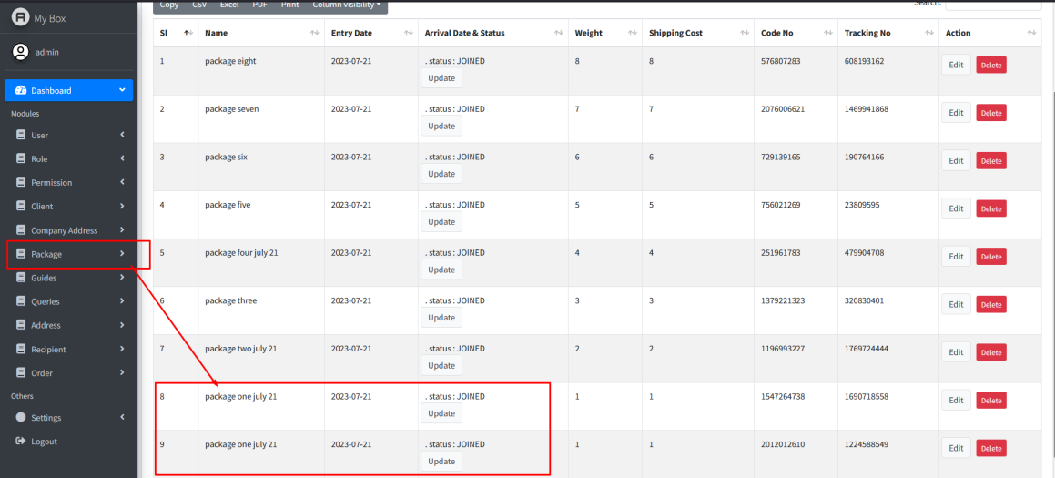

1. Path: Client account>>address>> Add: design issues of placeholders and identification number box takes letters as input.

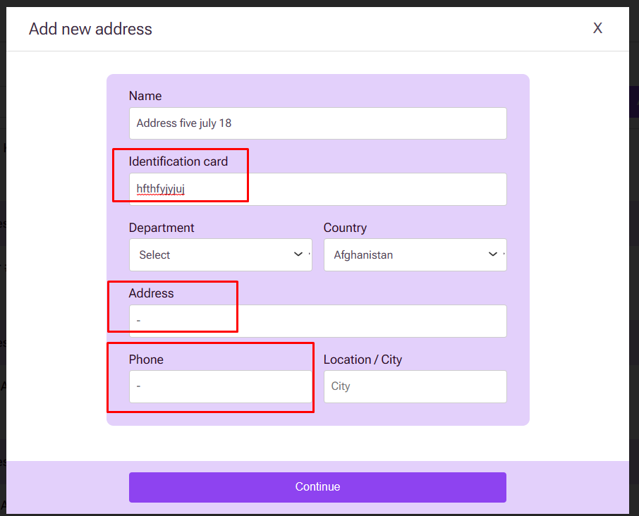

1. Alignment issue: path: client>> address

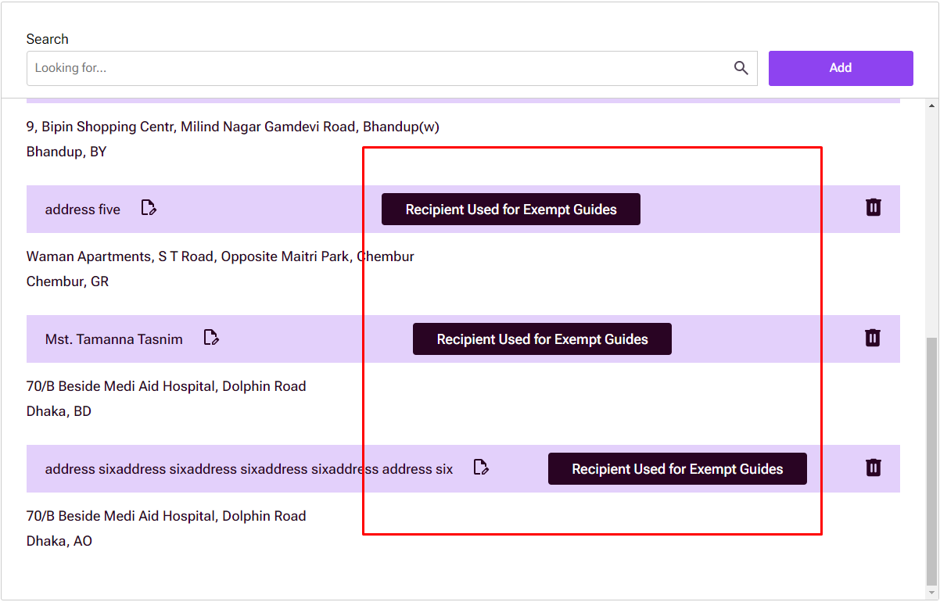

1. Update user address option doesn’t contain existing address in the field.  
   path: client account>> address>> update address(mentioned in red box in the following image)

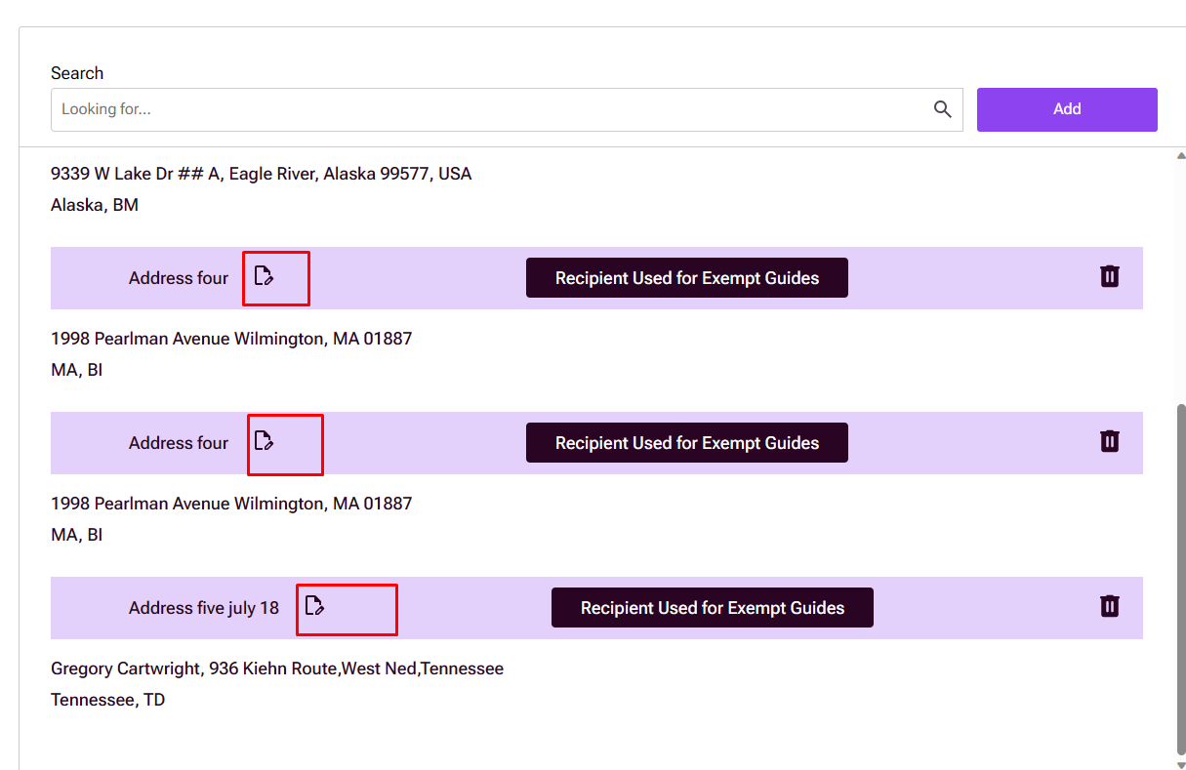

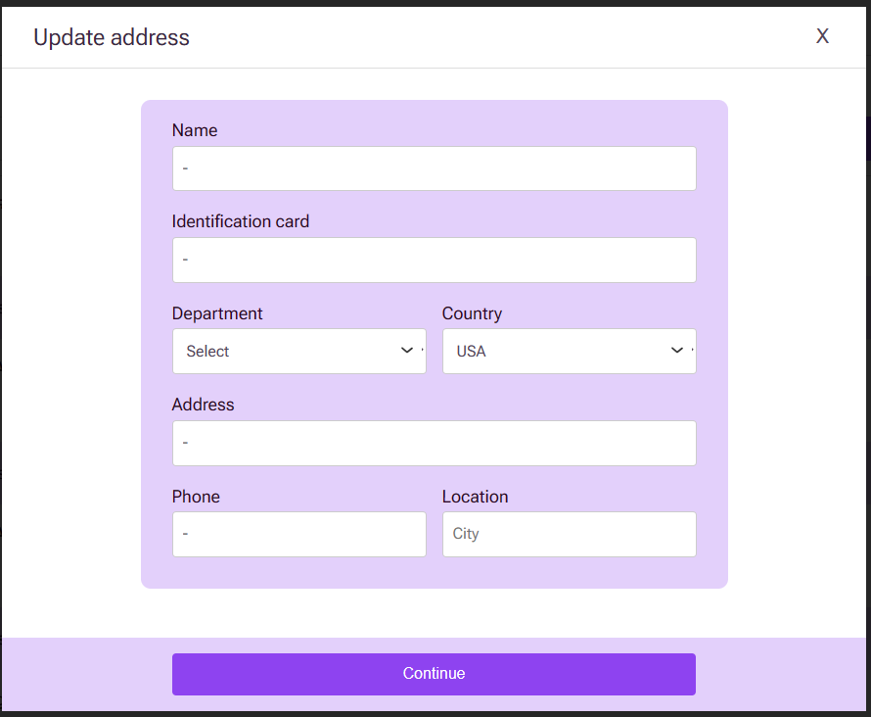

1. No link provided in the following buttons:

Path: Client account>> Footer

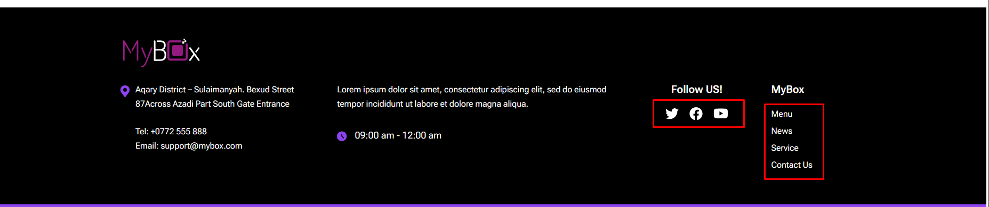

1. Path: Client account>> Packages>> Fractionate>>Send Fractionation> 419 error.

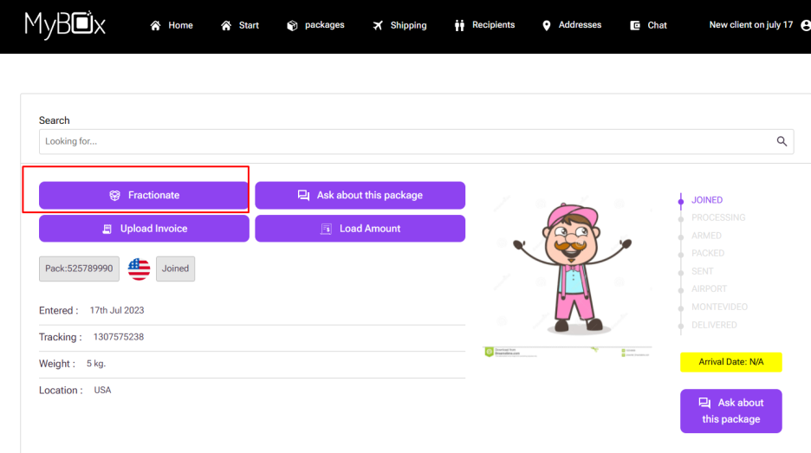

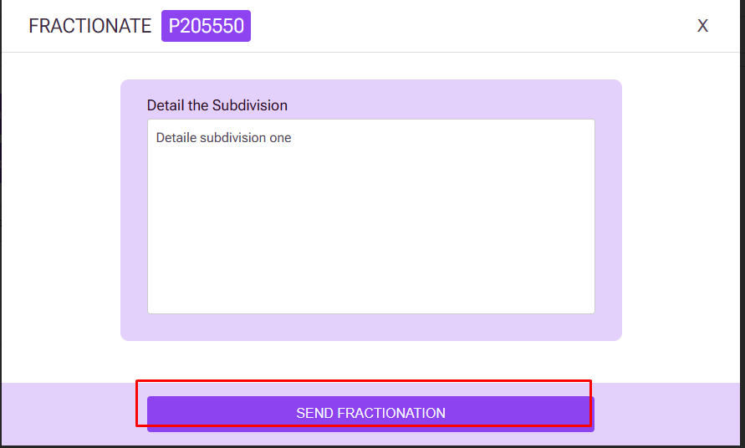

Design issue on the same page:

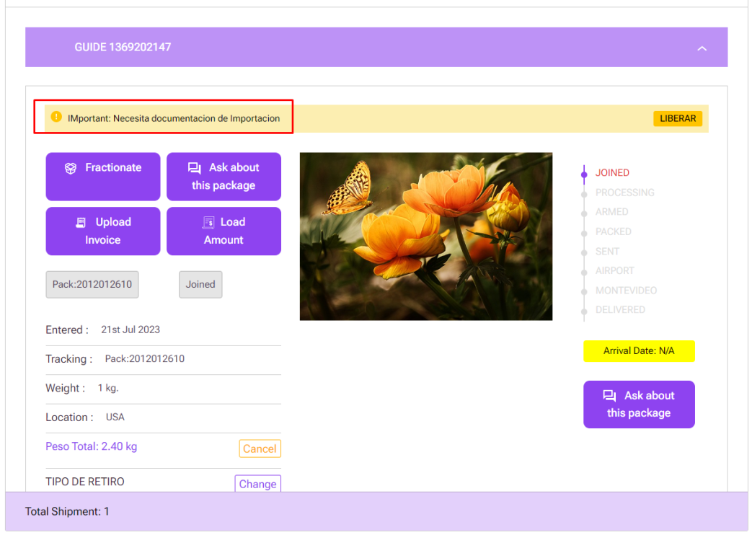

Client account>> shipping>> ask about this package>> 419 page not found error

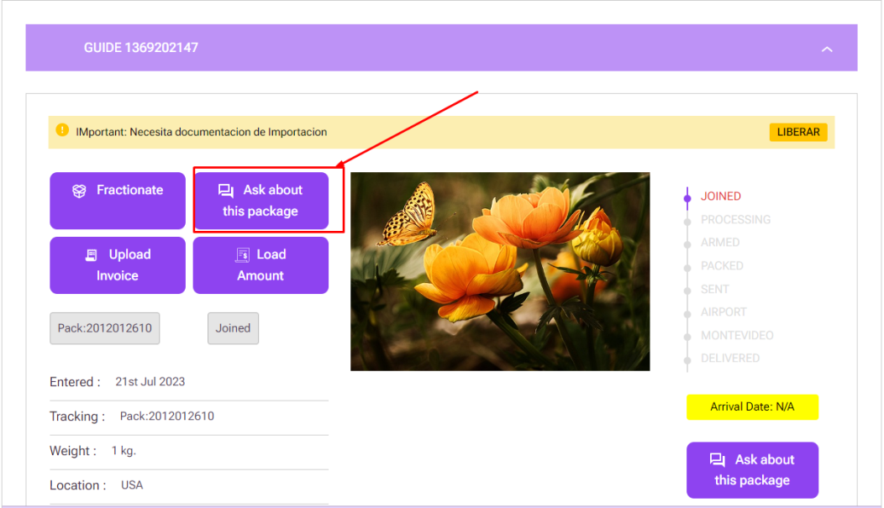

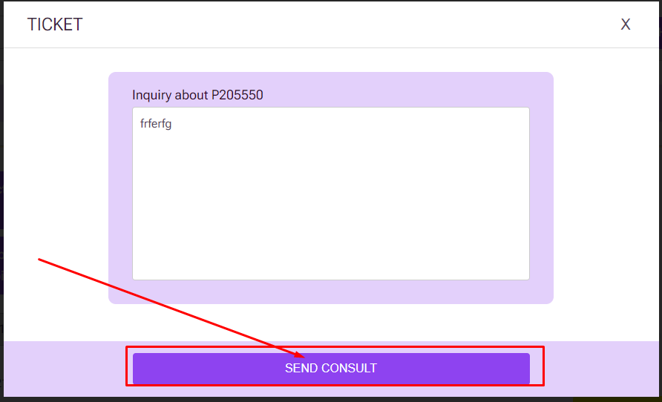

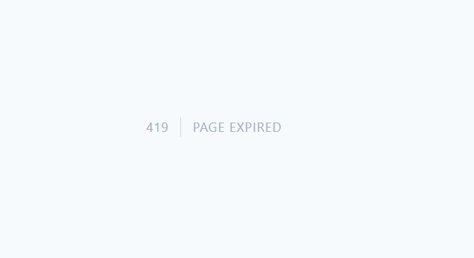

1. Button is not clickable: path: client account>> packages

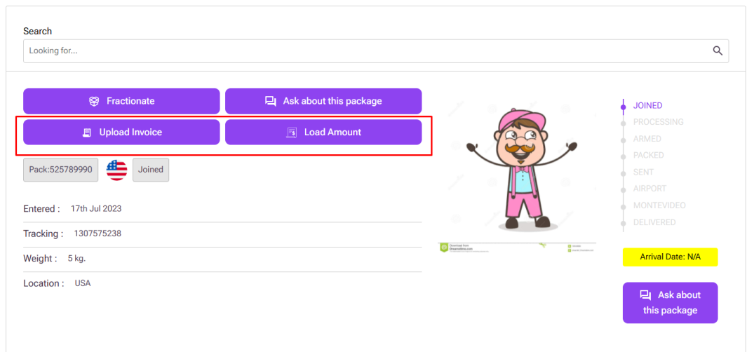

1. Design issue: path: client account>> packages>> send package

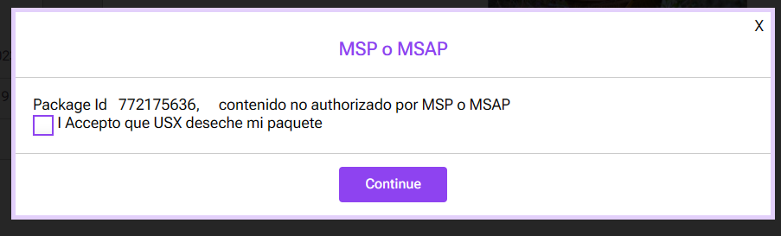

1. No real content on package guide box and Type of guide;

path: client account>> packages>> send package>> package guide>>type of guide

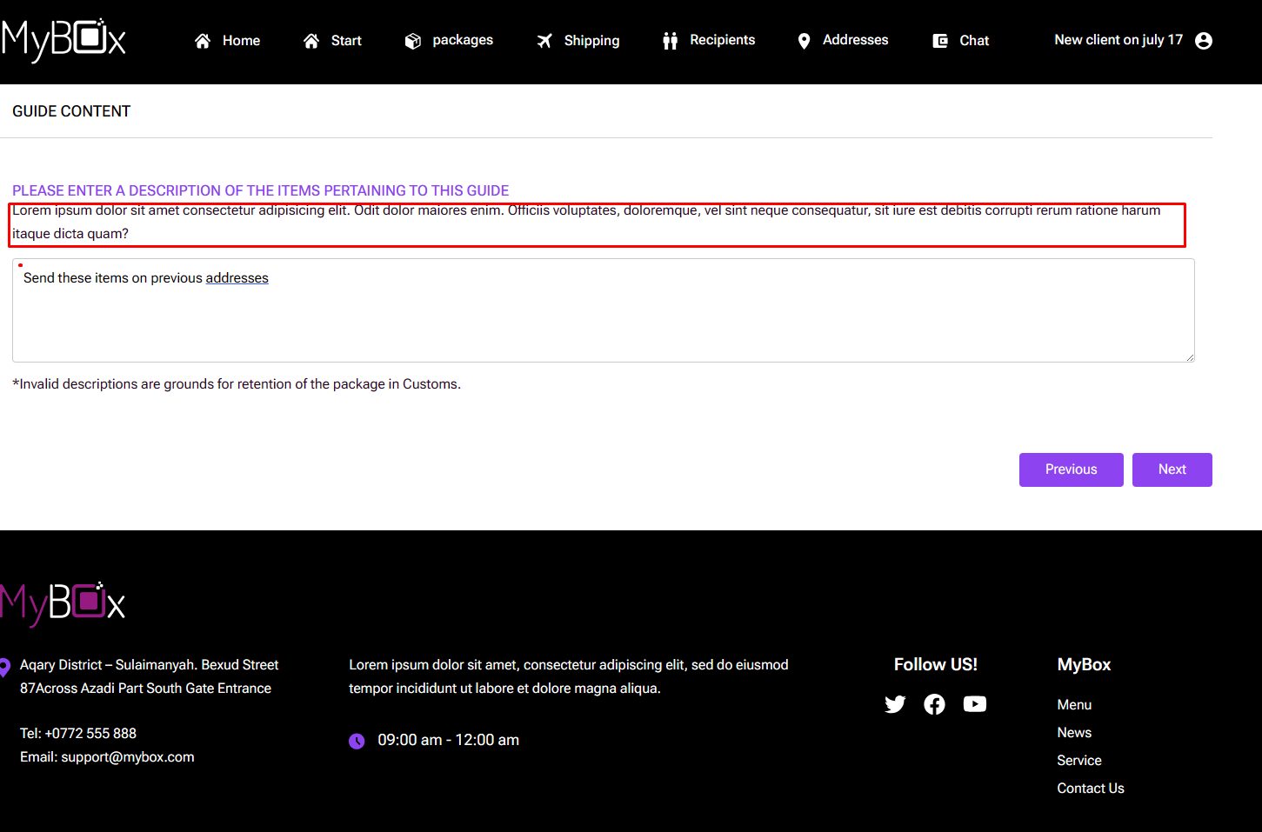

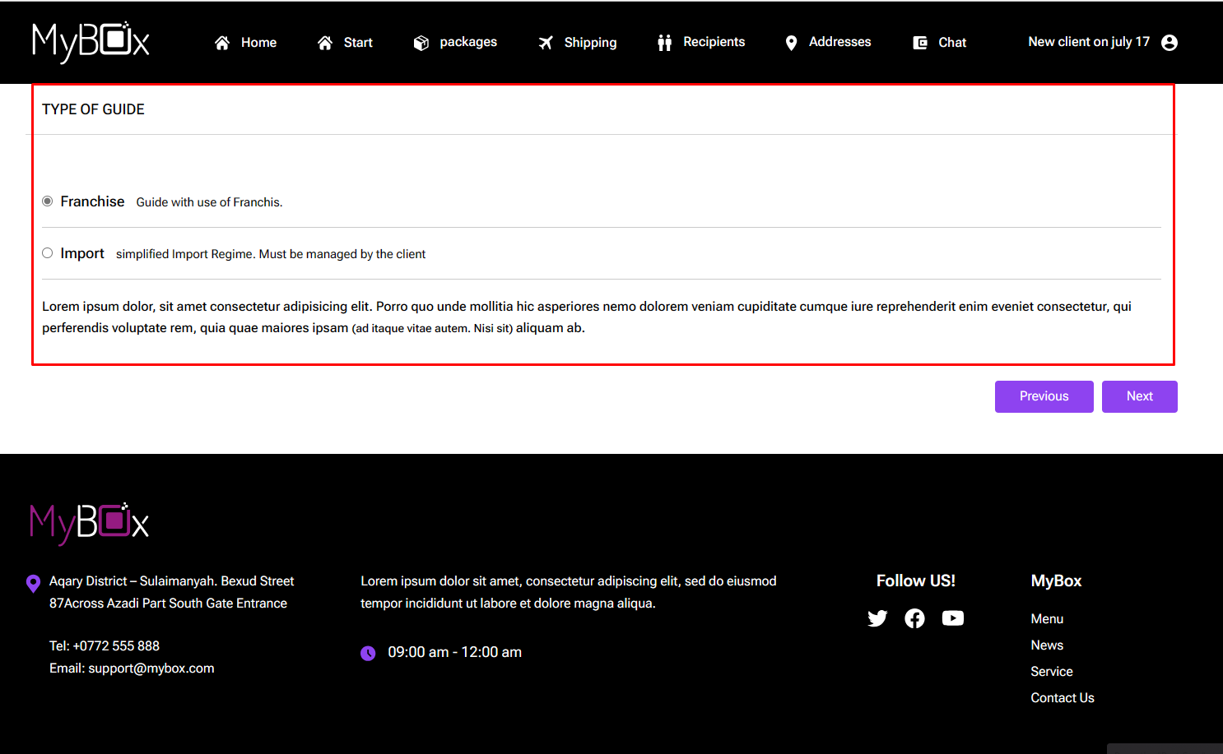

In the following image, previous button gives 404 not found error.

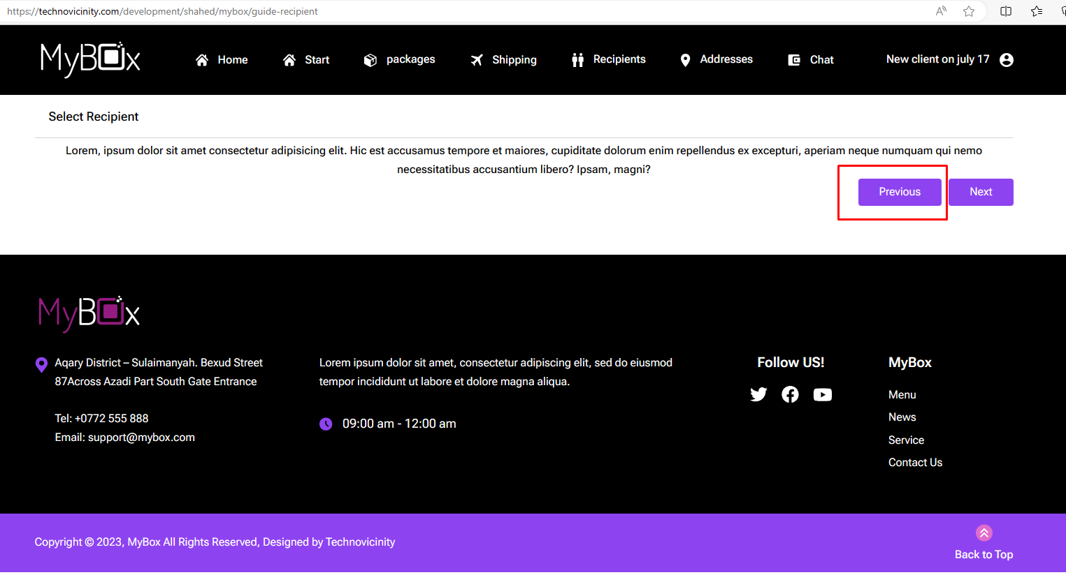

Design issue: <https://technovicinity.com/development/shahed/mybox/guide-recipient>

Path>> client account>>package>>send package>>guide recipient

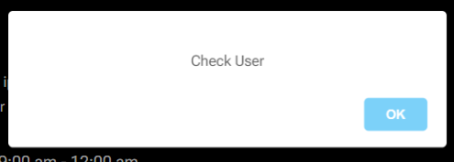

1. Client account>>recipient >>add new recipient>> date field>> date field contains 32 as date. Also, there is no validation for giving future date as birthday.

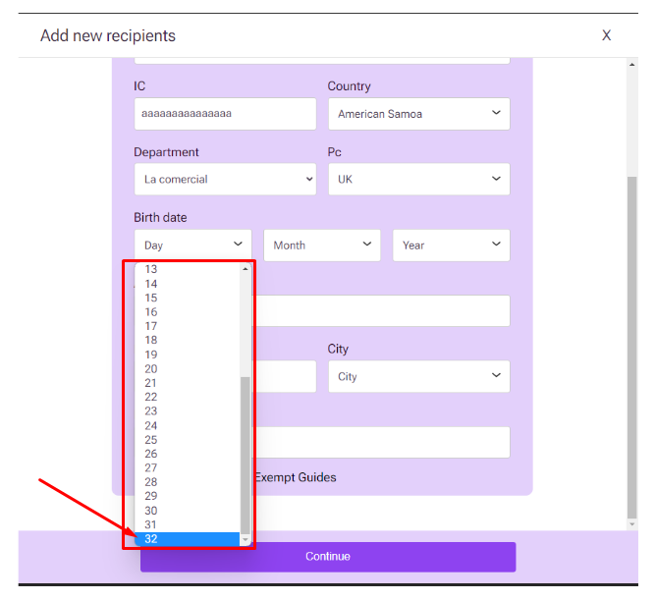

1. Alignment issues: path: client account>> recipient>>Add

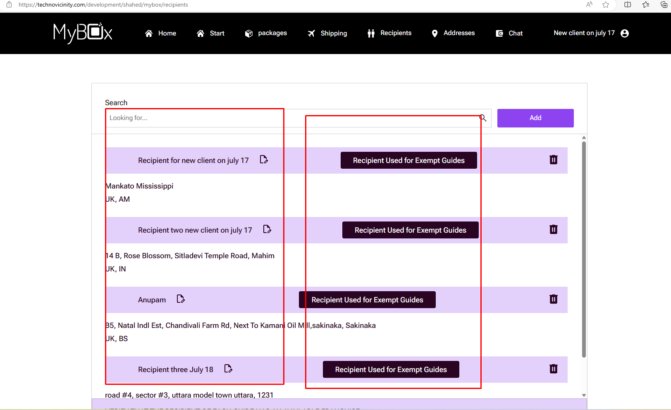

1. Delete button is not functioning. Path>>client account>> address>> delete.

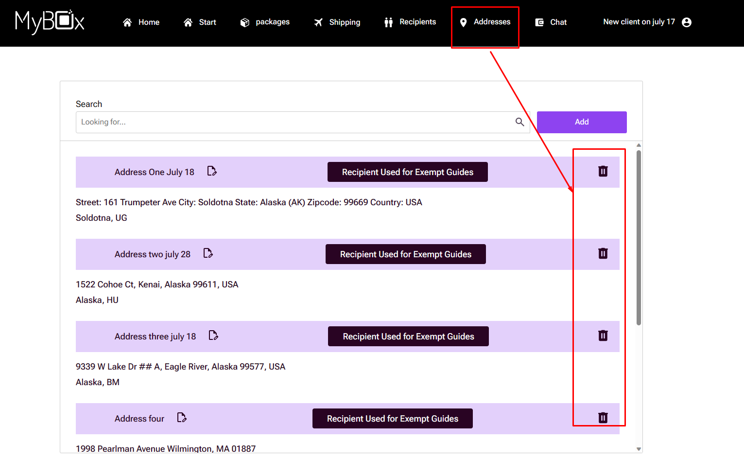

1. Delete button is not working. Path: client account>> recipient>> delete

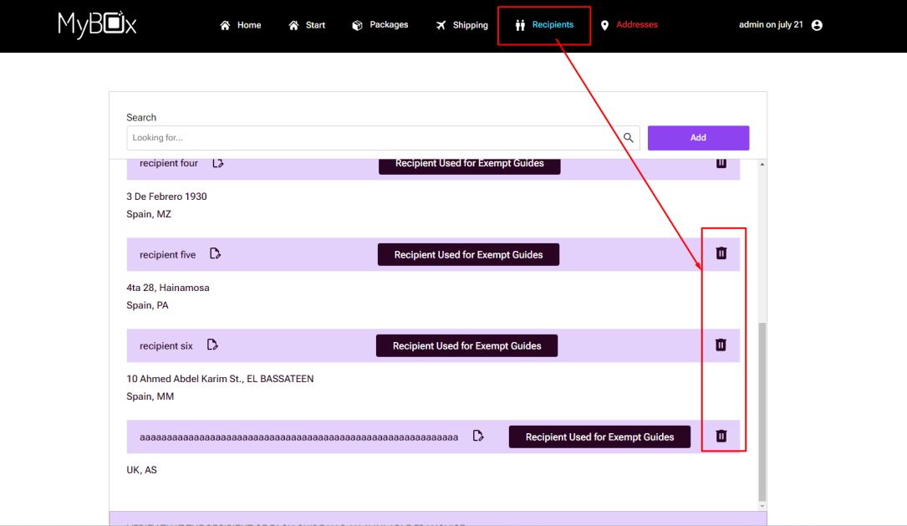

1. Admin>> package>> edit>>update status>> date field for each package remains the same if I set date for one package.

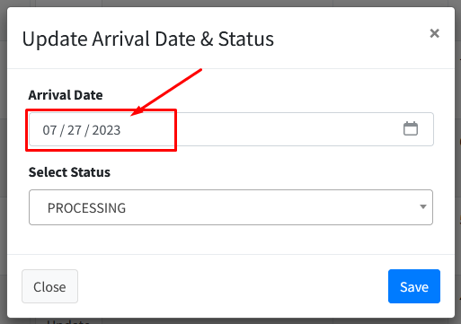

1. Button issues: Path: client account>> Start>> Make a payment (404 not found) and Advance payment buttons (not clickable).

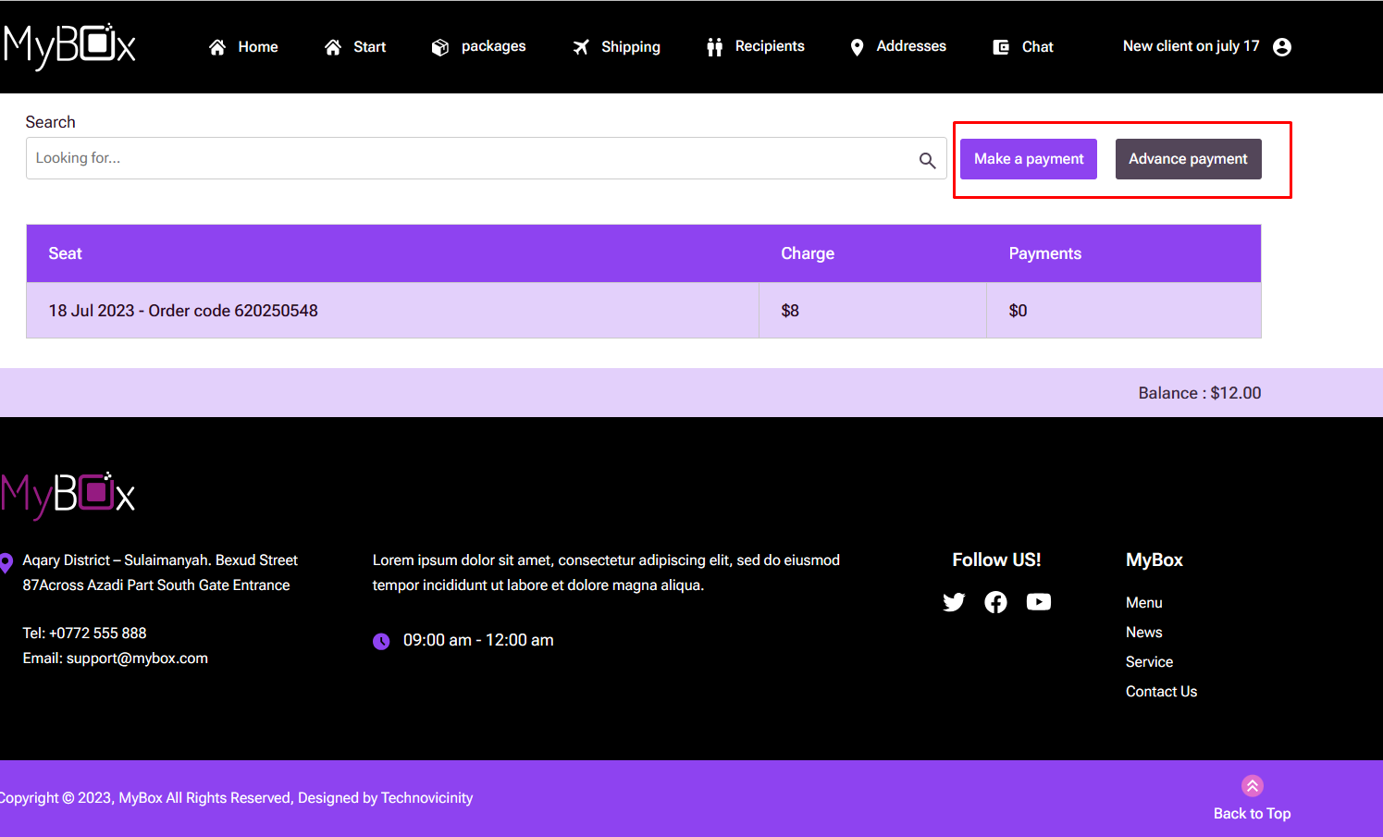

1. Buttons are not clickable. Path: client’s account>>shipping

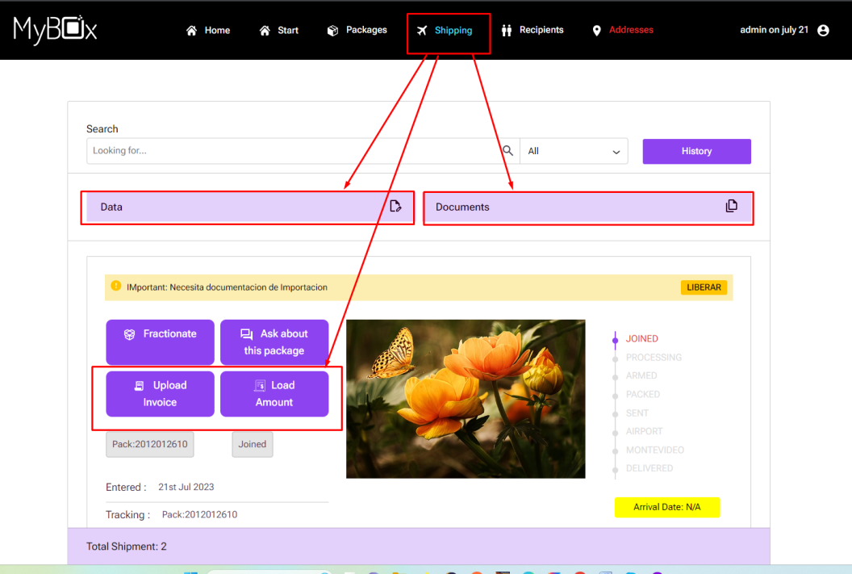

1. Admin>> address>> gives following error.

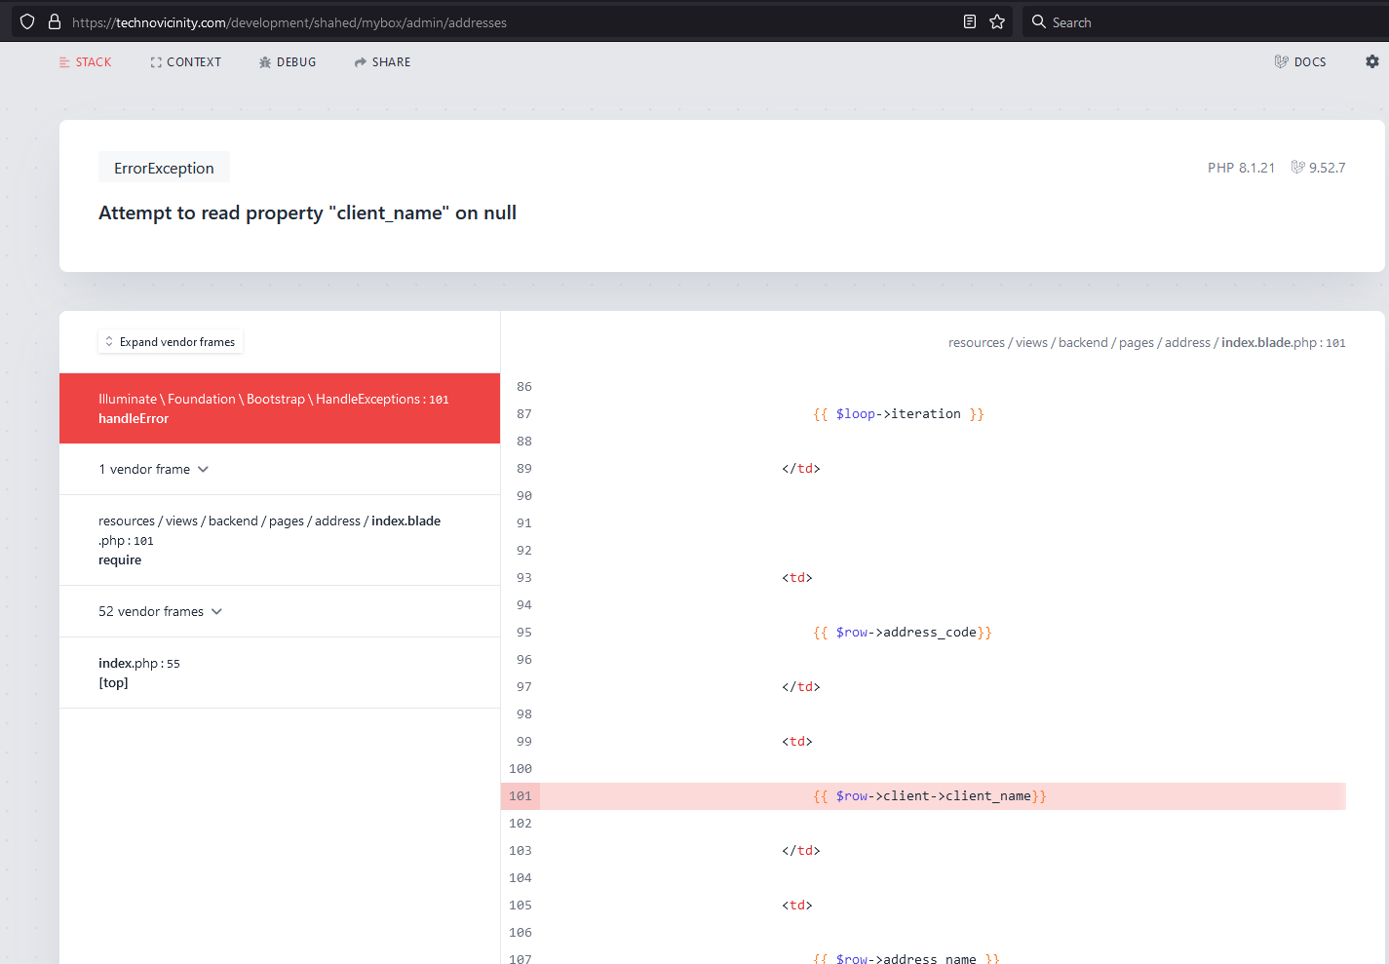

Admin>> recipient>>gives following error.

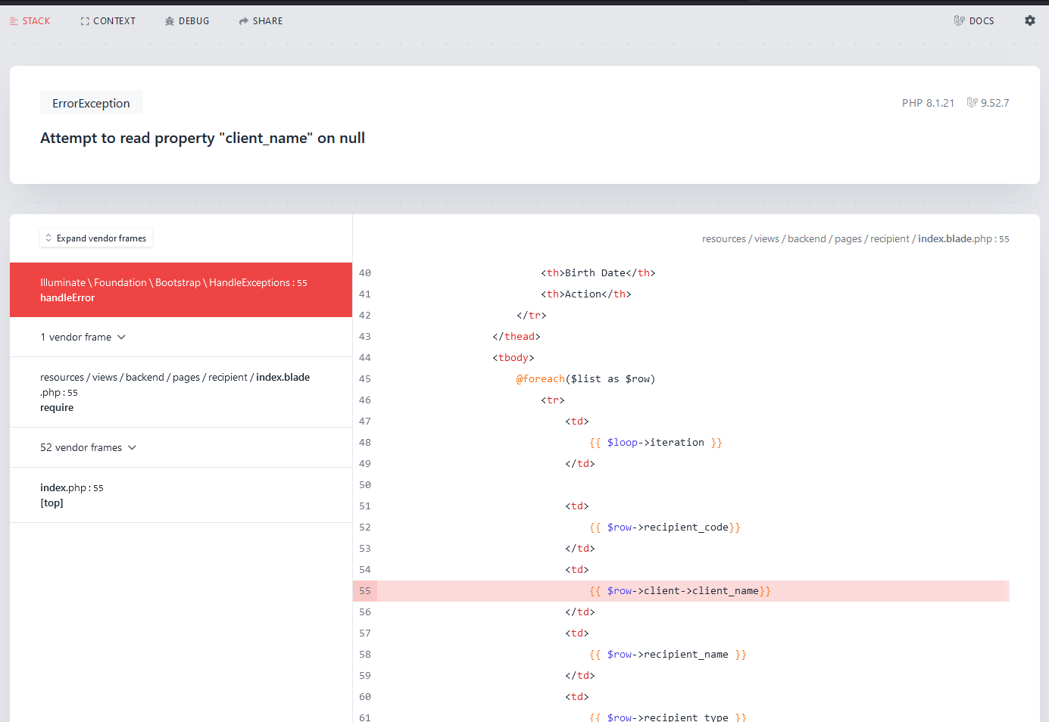

Admin>> orders>> gives following error.

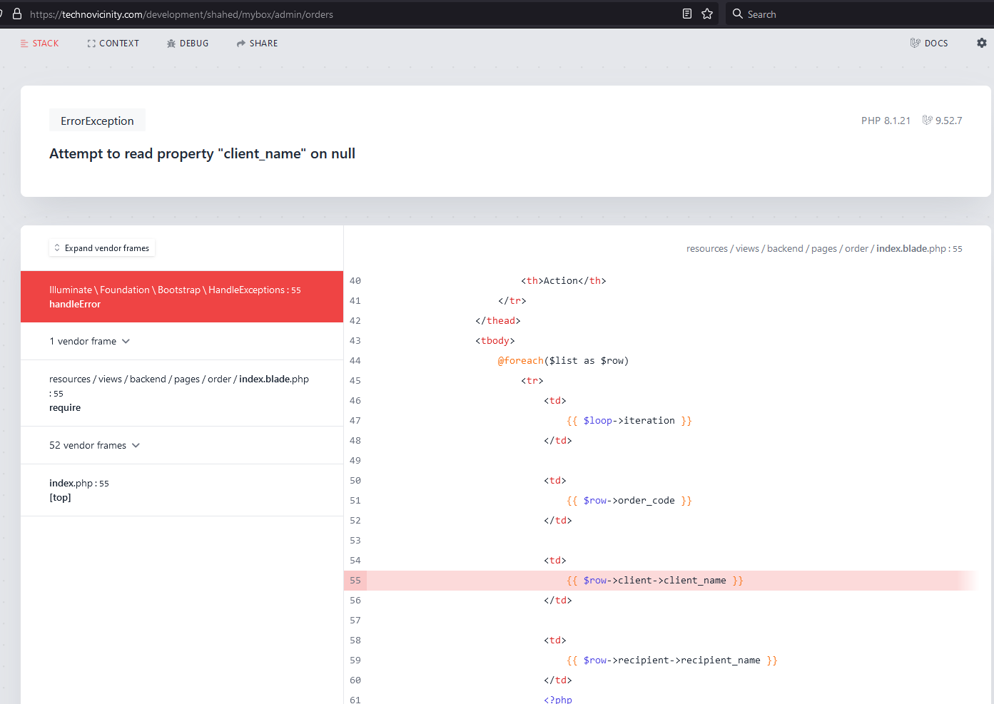

1. No real content in the MyBox homepage: Also design needs improvement.



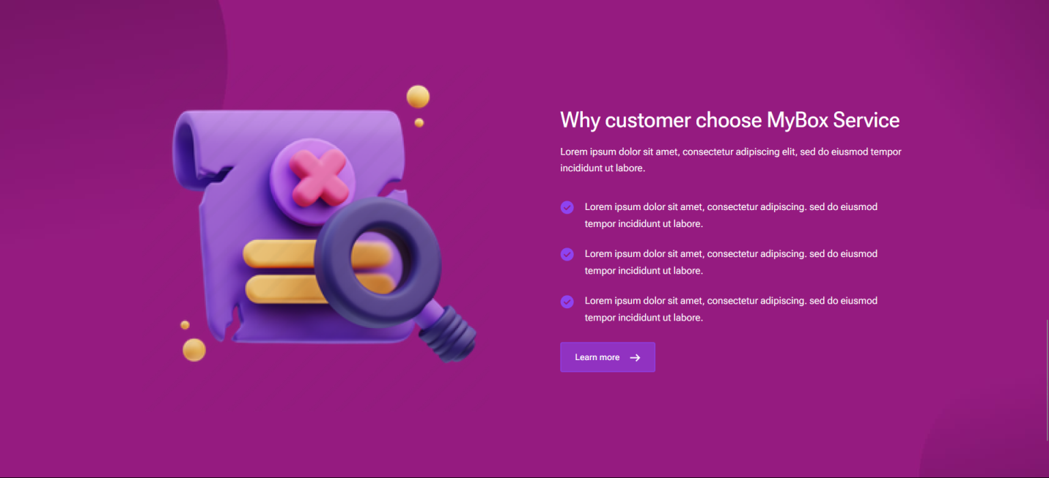

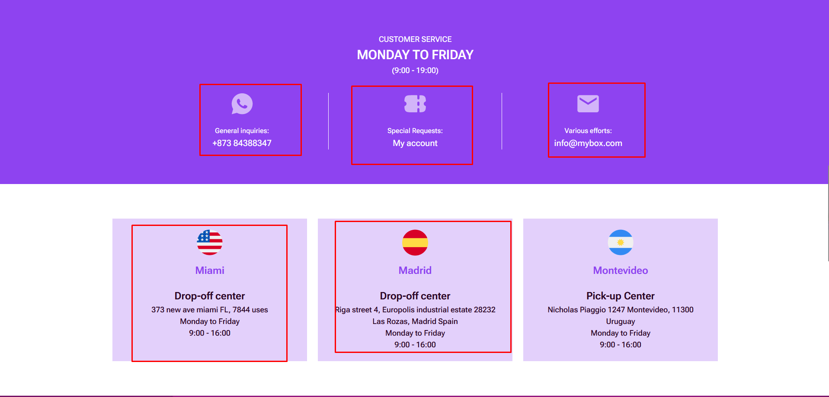

Client account: Home>>My queries>> 404 not found error.

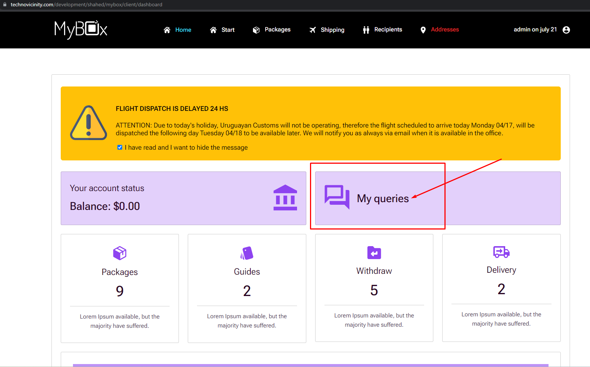

No real content in client homepage.

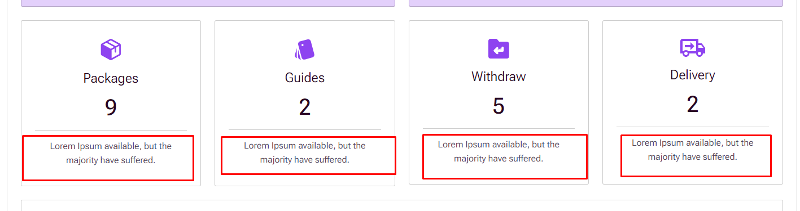

Design issue and following button doesn’t work.

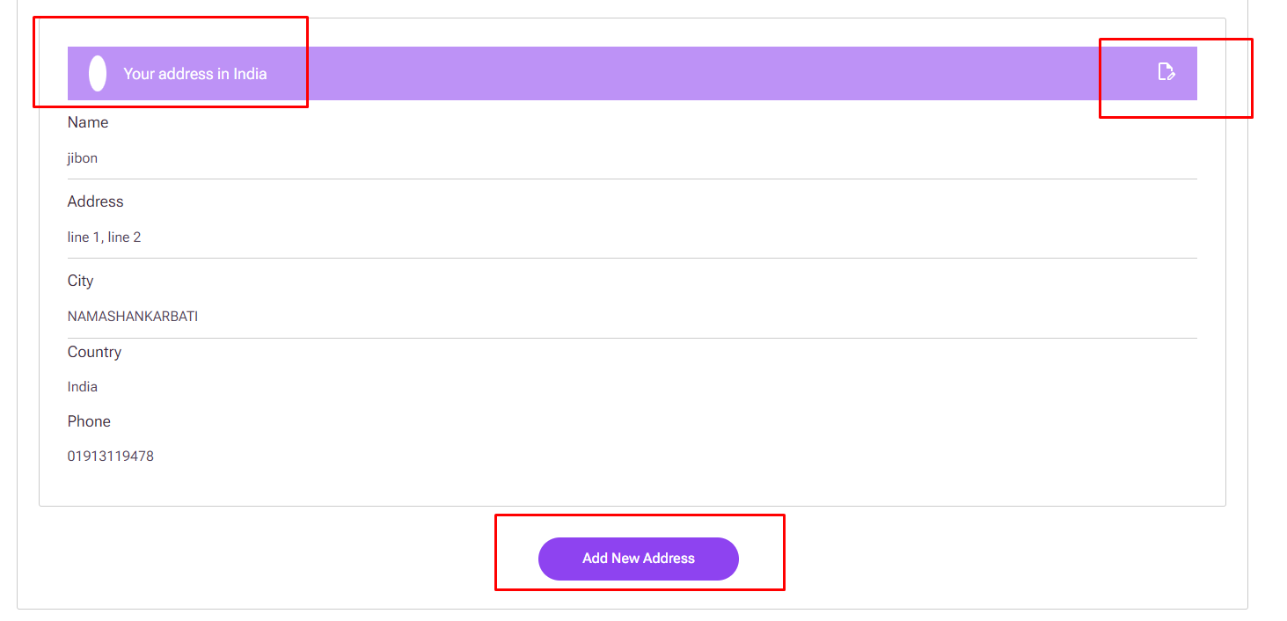

Client account>> packages>> search button doesn’t work

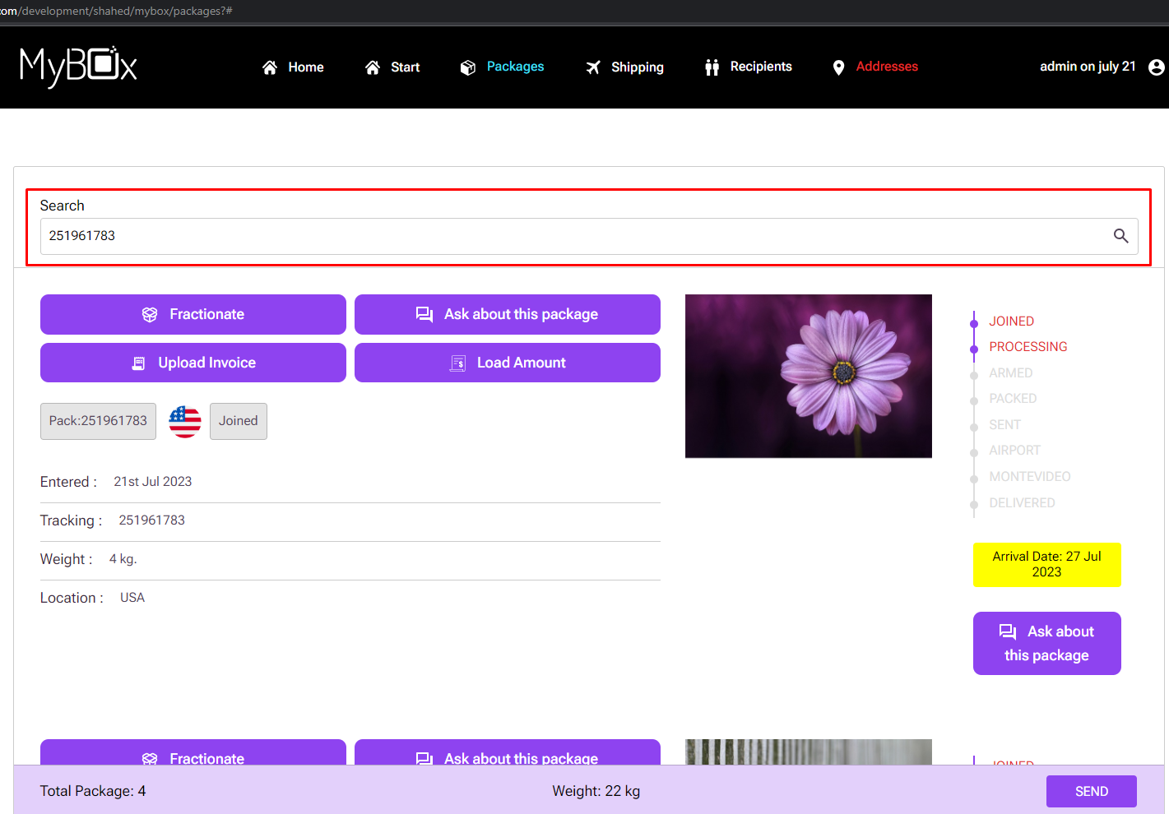

Client account>>shipping>> design issue

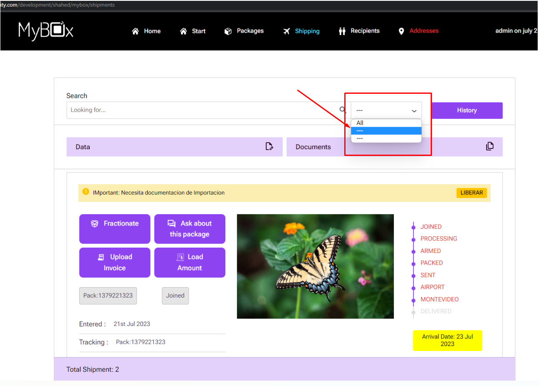

Client account>>recipient>> search button doesn’t work

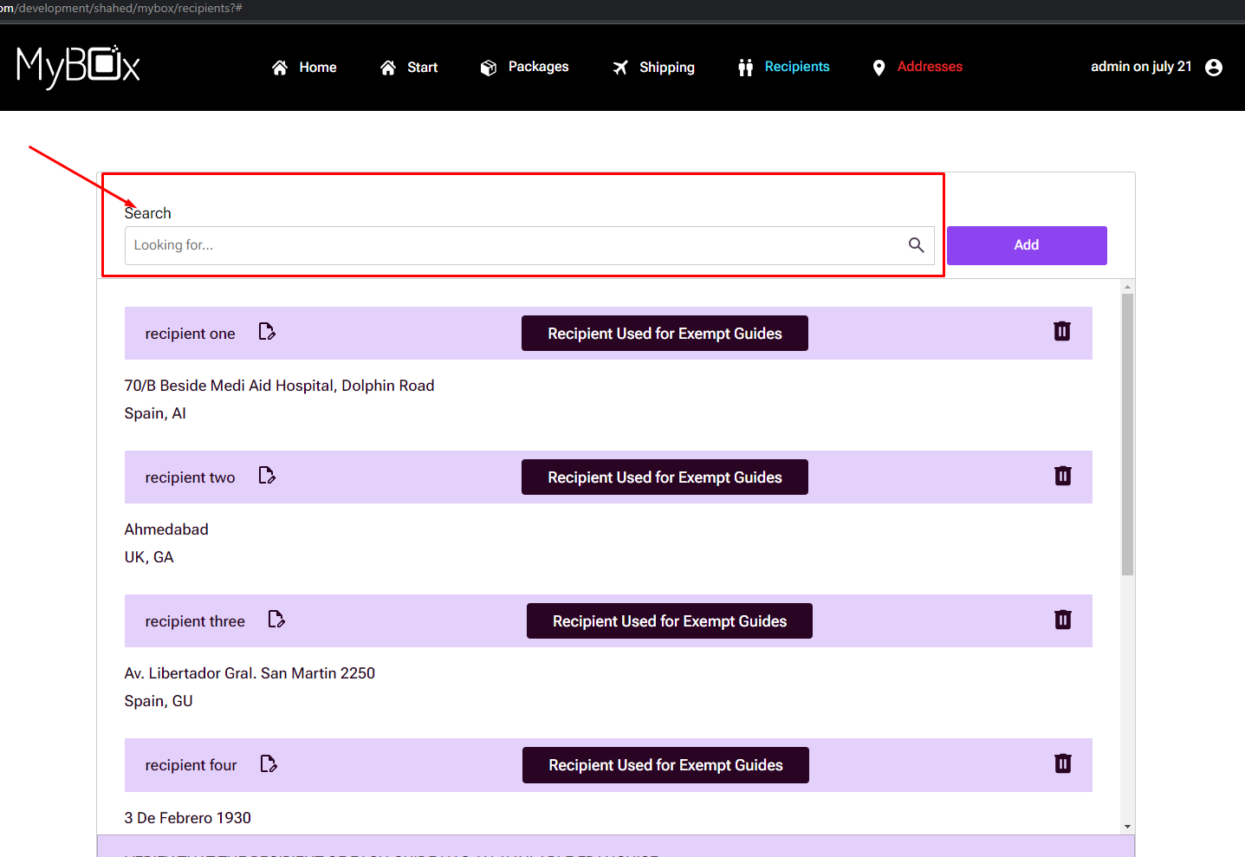

Client account>> address>> search button doesn’t work.

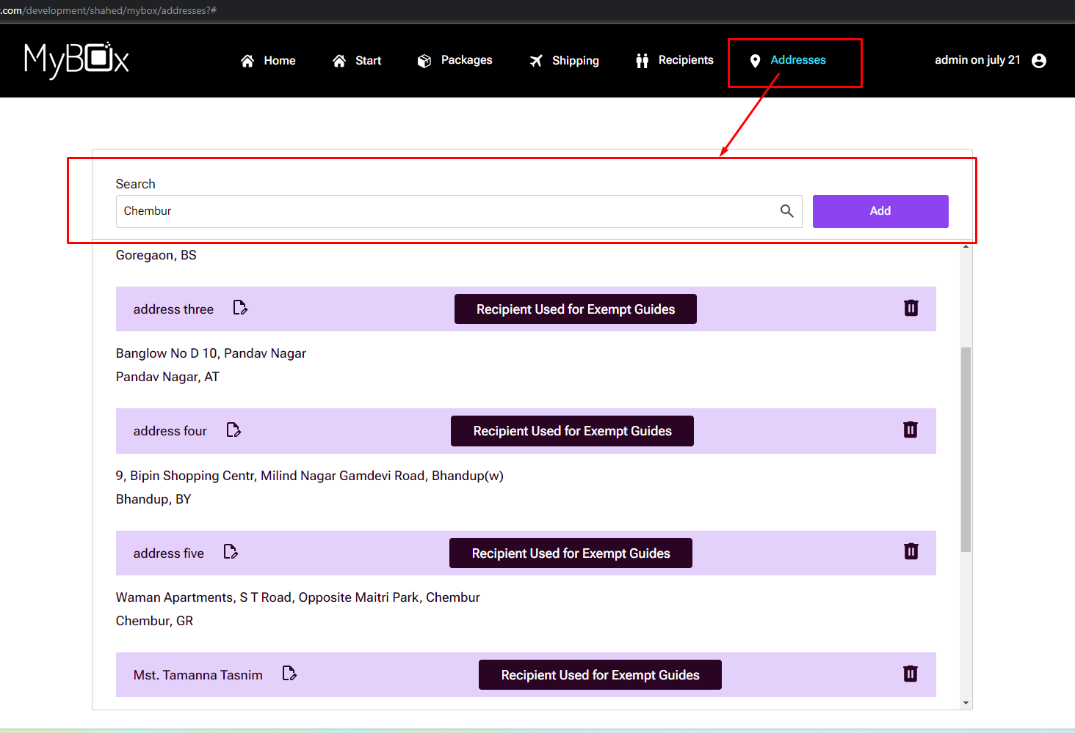

Client account>> my queries>> Design needs improvement and logo issue in the footer.

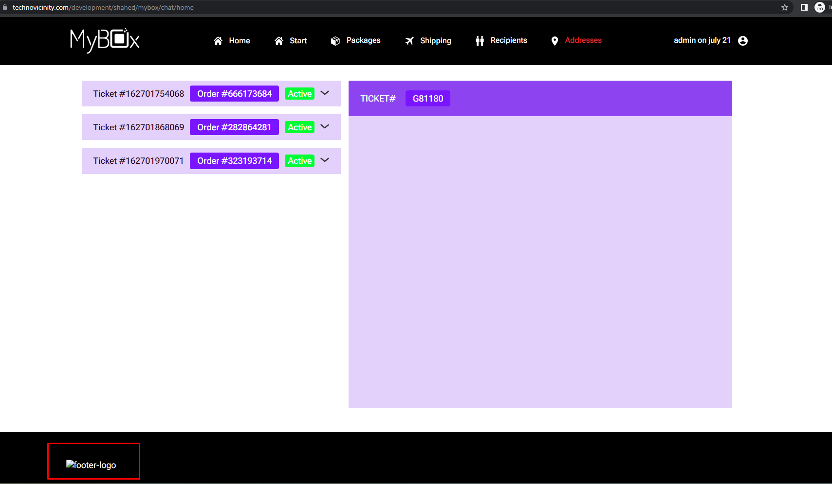

Client account>> my account>> design issue:

